# load the dataset inside PIG

Load_Data = LOAD ‘/home/prateek/Documents/PIG/Pokémon.csv’ USING PigStorage(‘,’) AS(Sno:int,Name:chararray,Type1:chararray,Type2:chararray,Total:int,HP:int,Attack:int,Defense:int,SpAtk:int,SpDef:int;Speed:int);

**Ques 1: Find the list of players that have been selected in the qualifying round (DEFENCE>55).**

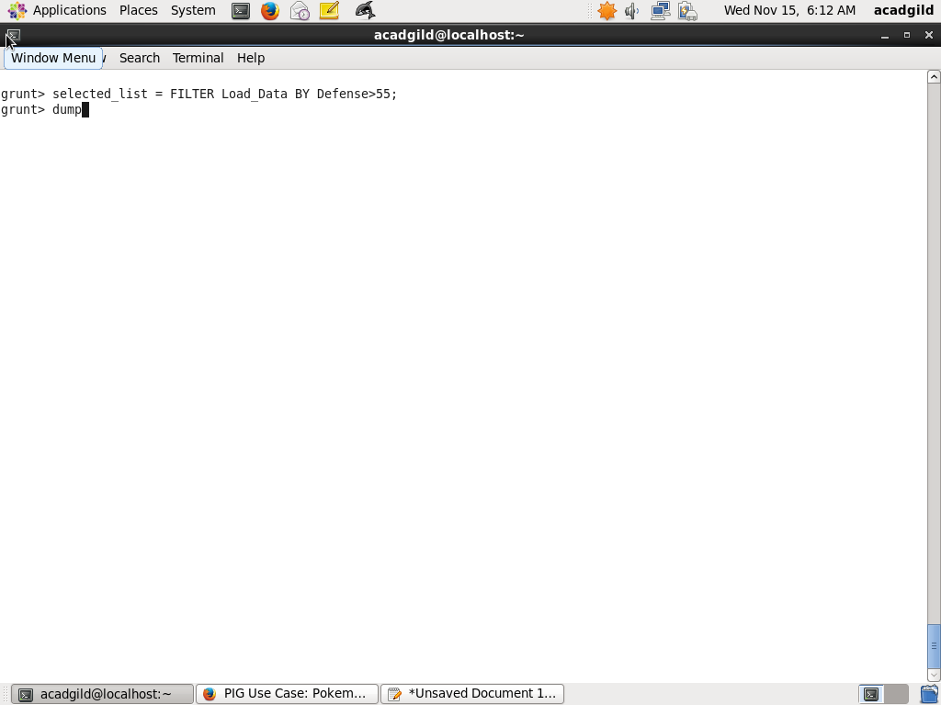

**Ques2:State the number of players taking part in the competition after getting selected in the qualifying round.**

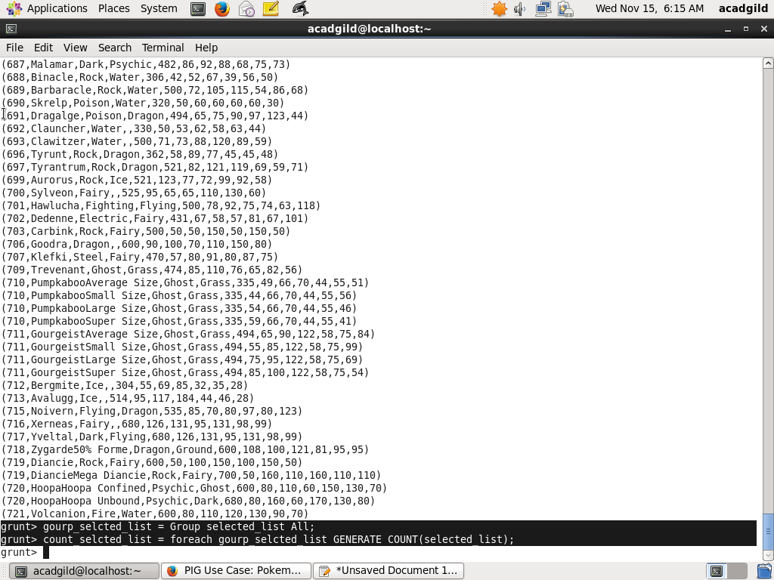

**Ques 3**: **Using random() generate random numbers for each Pokémon on the selected list.**

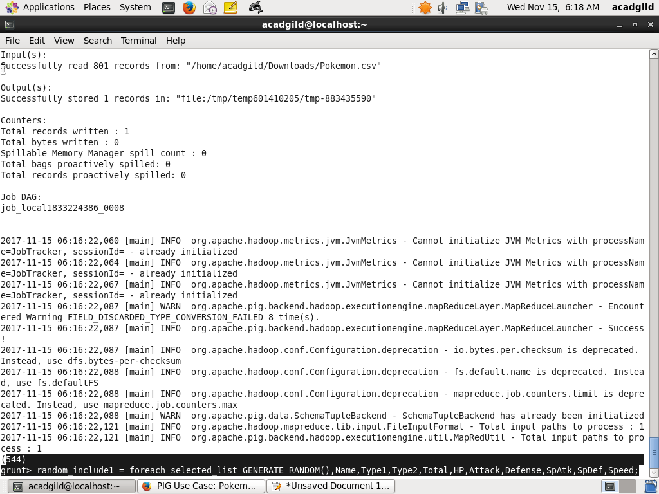

**Ques 4**: **Arrange the new list in a descending order according to a column randomly.**

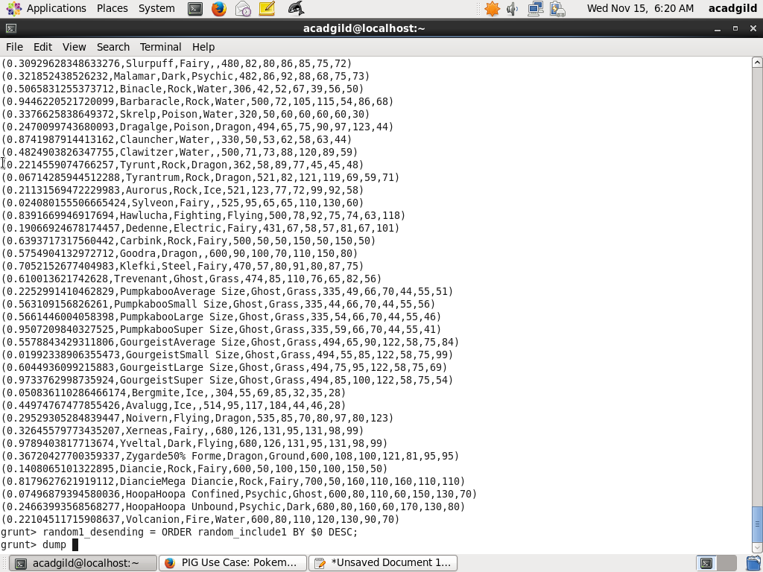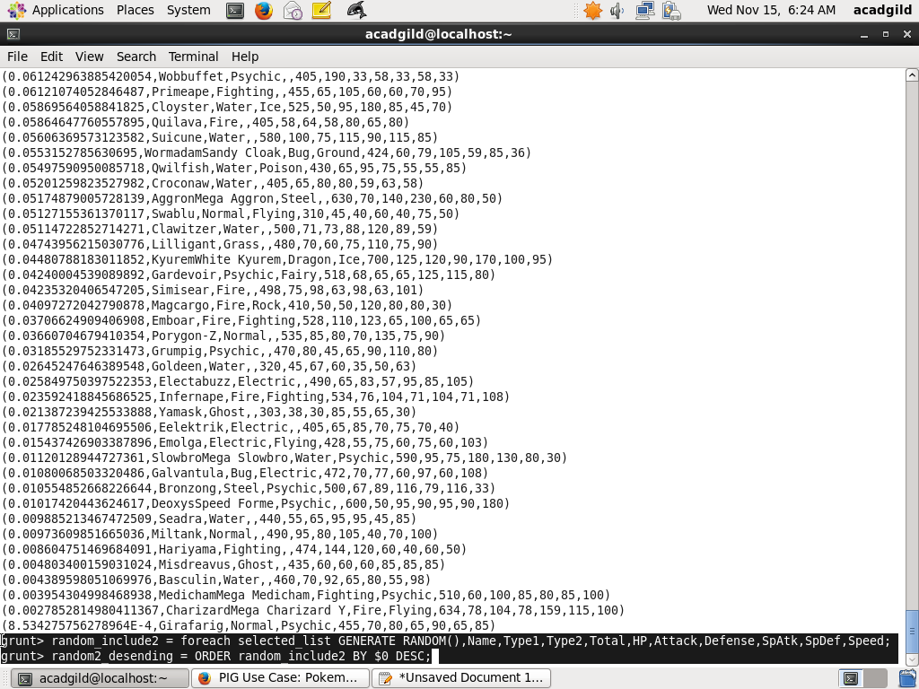

**Ques 5**: **Now on a new relation again associate random numbers for each Pokémon and arrange in descending order according to column random.**

**Refer screenshot above**

**Ques6**: **From the two different descending lists of random Pokémons, select the top 5 Pokémons for 2 different players.**

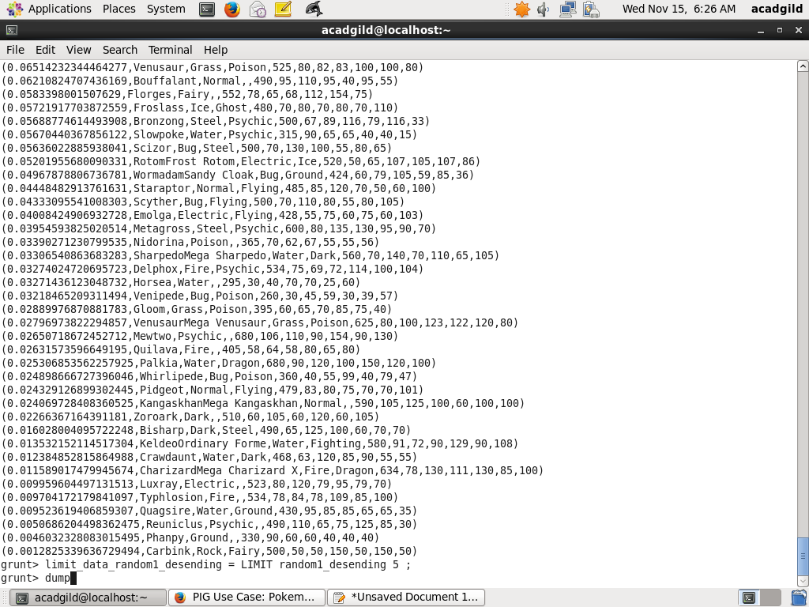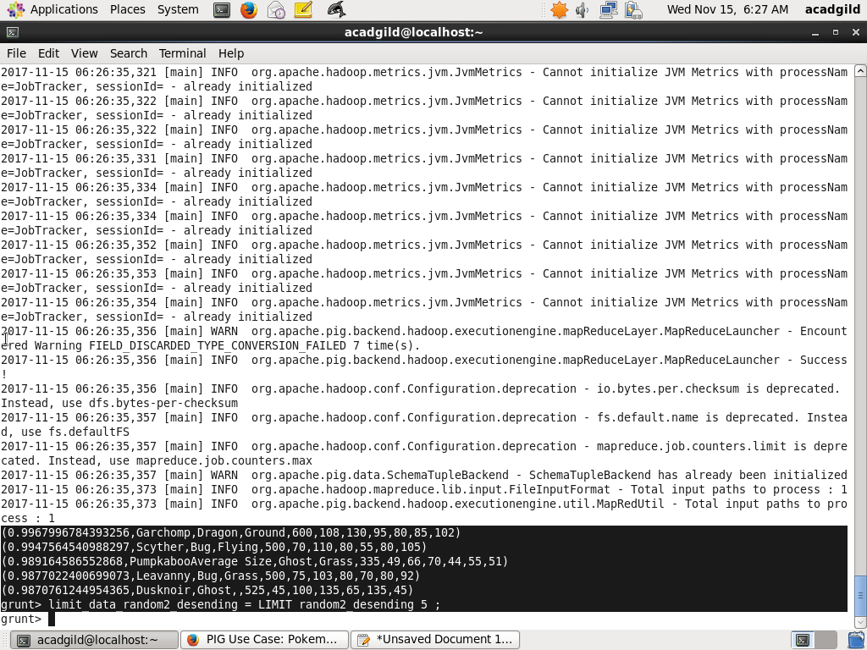

**Ques7**: **Store the data on a local drive to announce for the final match. By the name player1 and player2 (only show the NAME and HP).**

